Full Title (Arial Rounded MT Bold)

Presenting Author¹
Co-Authors²

¹ Organization, Address, City, Country
² Organization, Address, City, Country
Contact@E-mail

Abstract (Calibri 11)

ONE page abstract format: including figures and references.

Please follow the model below.

References

- Reference 1 (Calibri 11)
- Reference 2
- Reference 3…

Figures

Figure 1. Calibri 10

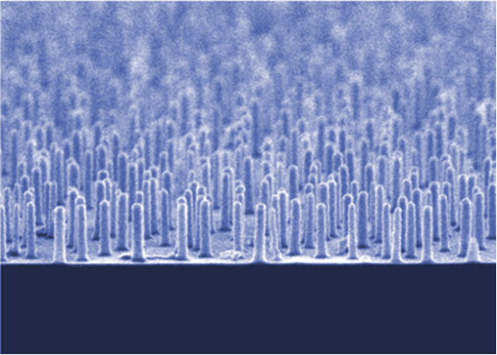

Figure 2. Calibri 10

